LAB8 – OFFSET, TRIM and EXTEND
OFFSET
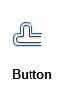
Enter Distance to Offset,
Specify Object to Offset,
Specify Point on Side to Offset

Exercise: Target Practice
Draw a CIRCLE with Radius of 1
OFFSET the CIRCLE – Distance is 0.5
OFFSET 1 time inside and 4 more outside of the original CIRCLE to Make a Target

TRIM
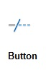
Select Cutting Edges
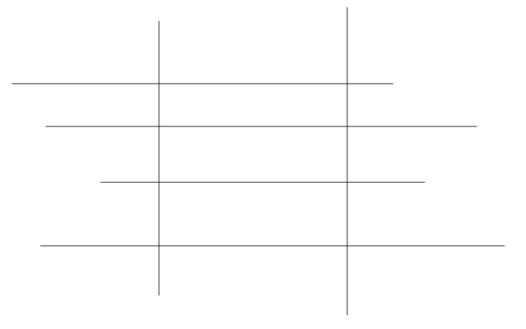
Select Objects (Remember, you can use a crossing window to select multiple objects)

Draw four horizontal lines similar to the picture below.
Add two vertical lines.
Use the VERTICAL lines as CUTTING EDGES. TRIM the Lines to make them the same length.

EXTEND
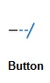
Select Boundary Edge
Select Objects (Use a crossing window for multiple objects)

Draw four horizontal lines similar to the picture below.
Add two vertical lines.
Use the VERTICAL lines as BOUNDARY EDGES. EXTEND the Lines to make them the same length

