LAB7 – POLYGONS and ARRAYS
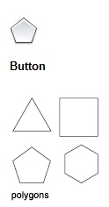
POLYGON
Enter Number of Sides (3-1024),
Specify Center of Circle,
Inscribed or Circumscribed,
Specify radius of Circle

Use POLYGON (You can type it or use the drop-down from the RECTANGLE button to find POLYGON)

Draw a TRIANGLE, Inscribed, with a Radius of 1
Draw a PENTAGON, Inscribed, with a Radius of 1
Draw an OCTAGON, Circumscribed, with a Radius of 1
Save As… LAB7P.dwg

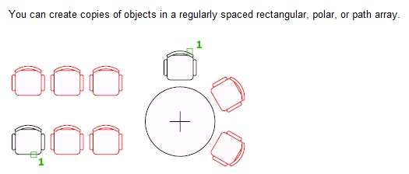
ARRAY

Select Objects
Enter Array Type (Rectangular, Polar, or Path)
For Rectangular…
Specify Opposite Corner for Objects
Space the Items
For Polar…
Select Objects
Enter the Number of Items
Enter the Angle to Fill (360 is a complete CIRCLE)

Create your own clock like you set in LAB6. Use a Polygon instead of a simple line for the hours. Fill in small lines for the minutes.
Save As…LAB7Clock.dwg
Create a Panel Door Like in LAB6.
Save Your Door as Lab7Door.dwg

