LAB3 – RECTANGLE
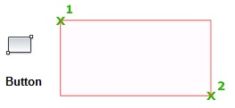
RECTANGLE (first point, second point)

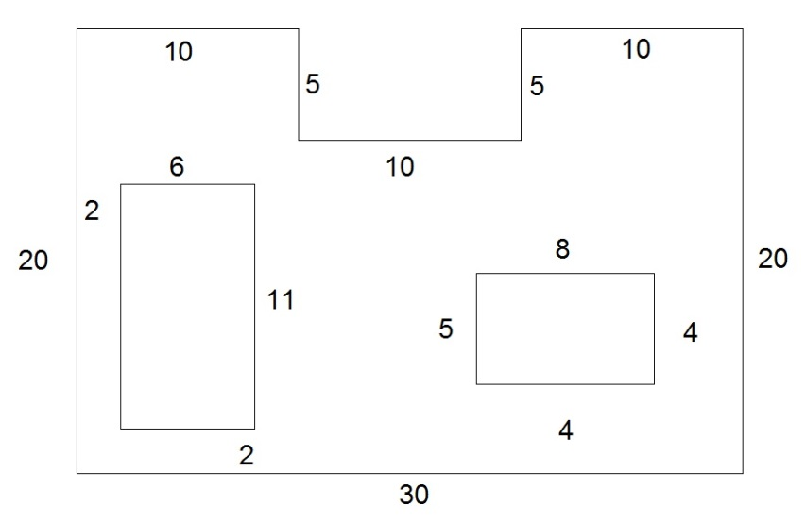
#1 Add two RECTANGLEs as shown using RECTANGLE, SNAP, and GRID to “LAB1.DWG”

SAVE AS…”LAB3.DWG”

