LAB10 – Dimensions and Text
Drawings need annotation with Text and Dimensions to better describe what we want to make.

DIMENSION - LINEAR, ALIGNED, RADIUS, DIAMETER, and ARC LENGTH
DIM LINEAR
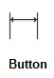
First Extension Line (or object),
Second Extension Line (or Options: Mtext, Text, Angle, Horizontal,Rotated)
Exercise: Size the Box
Draw a RECTANGLE
SELECT DIMLINEAR
DRAW THE WIDTH AND HEIGHT OF THE RECTANGLE
Save As… “LAB10Linear.dwg”

DIM ALIGNED
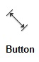
First Extension Line (or object),
Second Extension Line (or Options: Mtext, Text, Angle)
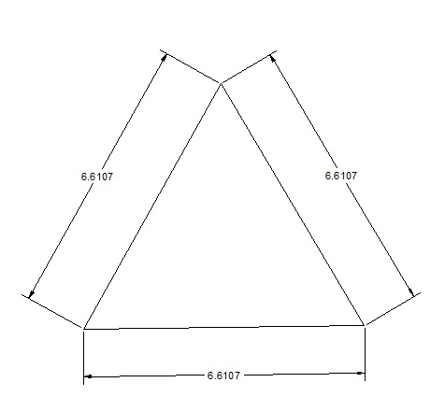
Exercise: Measure the Side
Draw a Triangle
SELECT DIMALIGNED
DRAW THE DIMENSIONS ALONG ALL THREE SIDES
Save As… “LAB10Aligned.dwg”

DIM ANGULAR
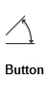
Select Arc, Circle, Line,
Specify Arc Location

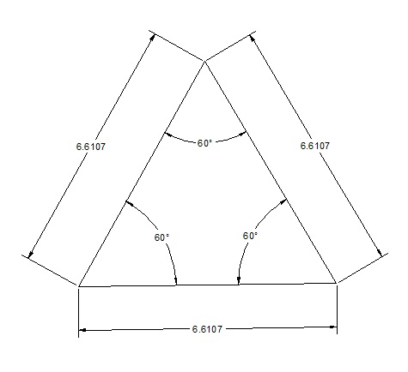
Exercise: Measure the Inside Angles
Go Back to Your Triangle or OPEN “LAB10Aligned.dwg”
SELECT DIMANGULAR
DRAW THE INSIDE ANGLES (Select two adjacent sides)
Save As… “LAB10Angular.dwg”

DIM RADIUS and DIM DIAMETER
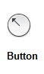
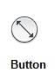
Select Arc or Circle
Specify Arc Location

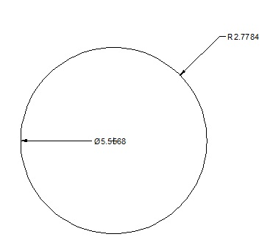
Exercise: Radius & Diameter
Draw a CIRCLE
Measure the RADIUS and DIAMETER using both tools.

Save As… “LAB10Rad.dwg”

DIM ARC LENGTH
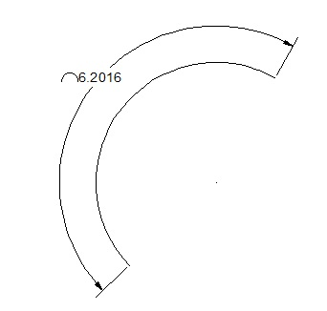
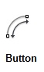
Select Arc or Circle
Specify Arc Length Location
Exercise: Arc Length
Draw an ARC (it’s next to CIRCLE)
Measure the length of the ARC.

Save As… “LAB10Arc.dwg”
TEXT
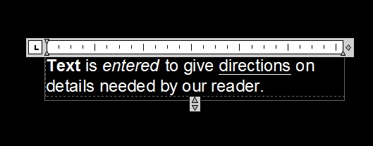
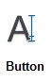
Multi-Line
Single Line

Exercise: TEXT
Enter Single Line and Multi-Line Text in any drawing. Experiment with Italics, BOLD, and Underlining.

Save As… “LAB10Text.dwg”

