LAB1 – LINE
LINE (from point, next point, undo, close)
Select LINE from Ribbon, Type “L” and hit <ENTER>, or select LINE from DRAW menu.
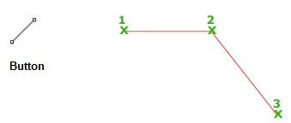

@ - Specify Coordinates (x,y) or Vector (Length & Angle) from Current Cursor
* - Specify from origin (0,0)
Options:
- By Clicking
  - from point Click on screen at location you want.
  - next point Click on next location.
  - Hit <ENTER> when done.
- Enter the x,y coordinates you want.
  - from point *0,0 <ENTER>
  - next point *0,5 <ENTER>
  - next point *5,5 <ENTER>
  - next point *5,0 <ENTER>
  - next point *0,0 <ENTER (or c <ENTER>)
- Pick a start point and enter DISTANCE and ANGLE.
  - from point *0,0 <ENTER>
  - next point @5<90 <ENTER>
  - next point @5<0 <ENTER>
  - next point @5<-90 <ENTER>
  - next point @5<180 <ENTER> (or c <ENTER>)
- After selecting the first point, move the mouse in the direction you want, and type the length you want.
  - from point Pick 1st point
  - next point Move mouse so the Line is straight up, type 5 <ENTER>
  - next point Move mouse to right in a straight line 5 <ENTER>
  - next point Move mouse straight down 5 <ENTER>
  - next point Move mouse to left in straight line 5 <ENTER> (or c <ENTER>)

#1 Draw the following using LINE.
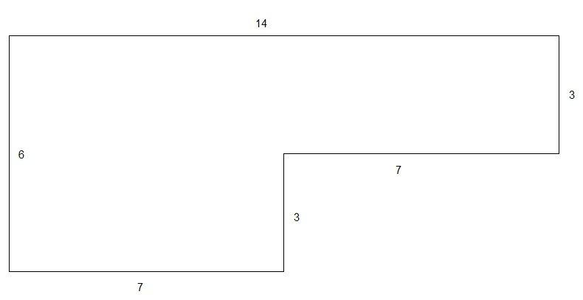

#2 Draw the following using LINE and ORTHO <F8>.

SAVE AS…”LAB1.DWG”

